Cryptography – CS 507 Computer Science and Engineering Department

Homework #3
- Even though extremely secure cryptographic algorithms are used, cryptosystems can sometimes be broken due to what is known as a protocol failure. This exercise demonstrates such a protocol failure, or a careless use of cryptographic algorithms. Let us assume Bob has an RSA cryptosystems with a very large modulus whose factorization is hard to find (e.g. the modulus is 1024-bit long). Alice wants to send a message to Bob by representing each alphabetic character as an integer between 0 and 25(i.e. A=0, B=1, and so on) and then encrypting each letter as a separate plaintext character using Bob’s public key.
  - Describe your cryptanalytic approach to break this cryptosystem.
  - Demonstrate that your approach is useful to break such an RSA cryptosystem using the following setting: Bob’s public key is (1113685117, 7) and Alice encrypted her plaintext and obtained the ciphertext (1, 16384, 410338673, 279936, 0, 35831808, 105413504, 893871739, 128, 105413504, 35831808, 16384, 612220032, 78125, 410338673, 105413504, 35831808, 1, 16384, 131730956, 0, 410338673, 35831808, 166314883, 2187, 166314883). Do not factor the modulus.
  - Describe your suggestion for fixing this problem. The goal is that the encryption function yields different ciphertexts for the same plaintext. (10 points)
- Oscar can easily prepare a dictionary of alphabet characters and their encrypted versions. The dictionary would be sorted and indexed according to the ciphertext column. Oscar can break an eavesdropped ciphertext into ciphertext characters and convert to plaintext by a simple and efficient dictionary lookup procedure.
- We prepare a table by first converting readable characters into integers in Z₂₆ and then by encrypting each integer using RSA with n = 1113685117 and e = 7.
A |  | B |  | C |  |  | D |  |  |  | E
0 | 0 | 1 | 1 | 2 | 128 |  | 3 | 2187 |  |  | 4 | 16384
F |  | G |  | H |  |  | I |  |  |  | J
5 | 78125 | 6 | 279936 | 7 |  | 823543 | 8 |  | 2097152 |  | 9 |  | 4782969
K |  | L |  | M |  |  | N |  |  |  | O
10 | 10000000 | 11 | 19487171 | 12 |  | 35831808 | 13 |  | 62748517 |  | 14 |  | 105413504
P |  | Q |  | R |  |  | S |  |  |  | T
15 | 170859375 | 16 | 2688435456 | 17 |  | 410338673 | 18 |  | 612220032 |  | 19 |  | 893871739
U |  | V |  | W |  |  | X |  |  |  | Y
20 | 166314883 | 21 | 687403424 | 22 |  | 266987654 | 23 |  |  | 63770096 | 24 |  | 131730956
Z
25 | 535090040

- One way of fixing this problem is to encrypt several letters at once. But even with this approach, RSA is still a deterministic cryptosystem, that is, the same sequence of plaintext letters maps to the same ciphertext. The encryption may be chained (e.g. CBC, OFB etc.) and the initial message text should be randomized, perhaps with a timestamp or a pseudo-random number.
- What is the output of the first iteration of the DES algorithm when the both plaintext and the key are all zero? (10 points)
The 64-bit input is x₀=00...0 (64-zeroes). The initial permutation has no effect. Hence L₀=00...0 (32-zeroes) and R₀=00...0 (32-zeroes). Applying the key schedule which is a fixed permutation on the input bits of the key yields the round key K₁= (00..0) (48-zeroes).
The round computes R₁=L₀ XOR f(R₀, K1)
The f-function
- First expands R₀ into 48-bit long bitstring using a fixed permuted expansion rule. Since only permutations and repetitions are used this will yield a 48-bit 0 string.
- The result is XORed with K1, which produces a 48-bit zero string.
- The 48-bit 0 string is divided into eight 6-bit chunks and the ith chunk is transformed under the rule specified in the Si box. 000000 is mapped 8 times with boxes Si i=1,..,8 and produces the following sequence of 4-bit values: 14, 15, 10, 7, 2, 12, 4, 13. In binary we obtain the following sequence:
1110 1111 1010 0111 0010 1100 0100 1101
- Finally the bit-string is permuted according to the P table to the following:
1101 1000 1101 1000 1101 1011 1011 1100
This is the result of f(R₀),K1)
The right half R₁=L₀ XOR f(R₀),K1) is simply the output of f(R₀),K1) since the L₀ is zero. L₁ = R₀ = (00..0) (32-zeroes). Concatenating both yields the following 64-bit string, which is the output of round 1.
0000 0000 0000 0000 0000 0000 0000 0000 1101 1000 1101 1000 1101 1011 1011 1100
- DES has a somewhat surprising property related to bitwise complements of its inputs and output. We will investigate the property in this problem. We denote the bitwise complement of a number A (that is, all bits are “flipped”) by A’. We want to show that if
y = DES_{k} (x)
then
y’ = DES_{k’} (x’).
This states that if we complement the plaintext and the key, then the ciphertext output will also be the complement of the original ciphertext. Your task is to prove this property. (20 points)
To prove the statement we make the following observations:
- The initial and final permutations are simple rearrangements and therefore do preserve the complements: IP(x') = (IP(x))' and IP⁻¹ (x') = (IP⁻¹ (x))'
- All rounds are identical; proving that one round generates a complemented output for a complemented input proves that all rounds behave similarly.
In round i, the following is computed
R_{i}=L_{i-1} ⊕ f(R_{i-1}, K_{i}).
In the computation of the f-function, the expansion of the input clearly preserves complements since its a simple permutation with some additional repetitions: E(x')=(E(x))'. Similarly the key-schedule preserves the complement. The XOR of K_{i} and E(x') yields K_{i}' ⊕ E(x') = K_{i}' ⊕ E(x)' = K_{i} ⊕ E(x). This follows from a basic property of the XOR function a' ⊕ b' = a ⊕ b. Thus, the input to the S-boxes will be identical to the uncomplemented case. Consequently, we end up with the following interesting property:
f(R_{i-1}', K_{i}') = f(R_{i-1}, K_{i})
The round computation becomes
R_{i}=L_{i-1}' ⊕ f(R_{i-1}', K_{i}')
R_{i}=L_{i-1}' ⊕ f(R_{i-1}, K_{i})
R_{i}= L_{i-1}' ⊕ 1 ⊕ f(R_{i-1}, K_{i}) = (L_{i-1} ⊕ f(R_{i-1}, K_{i}))'.
This shows that the right half is complemented when the input and the key is complemented. The left half is simply the copy of the right half in the previous round. Hence, the entire output is complemented.
- Let K = 111…111 be the DES key consisting of all 1’s.
  - Show that if DES_{K} (x) = y, then if DES_{K} (y) = x, so encryption twice with this key returns the plaintext.
  - Find another key with the same property as K in part (a). (20 points)

a. If the following condition for round keys hold the encryption operation in DES will be identical to decryption operation:
K_{i} = K_{17-i} for 1 ≤ i ≤ 16
It is easy to see that this condition holds when a DES key is all ones or all zeros.
b. All zeros key would be trivial for this. The four DES weak keys and the corresponding C₀ and D₀ pairs are shown in the table below.
Weak keys (hexadecimal) | C₀ | D₀
0101 0101 0101 0101 | All zeros | All zeros
FEFE FEFE FEFE FEFE | All ones | All ones
1F1F 1F1F 0E0E 0E0E | All zeros | All ones
E0E0 E0E0 F1F1 F1F1 | All ones | All zeros
- (AES) Show the first eight words of the key expansion for a 128-bit key of all zeros in AES. (10 points)

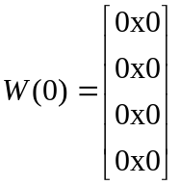, 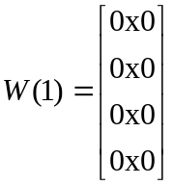, 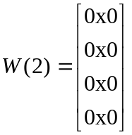, 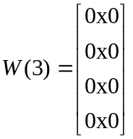
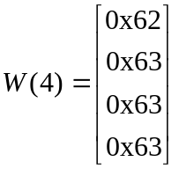, 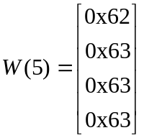, 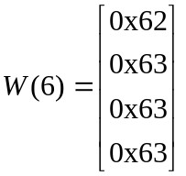, 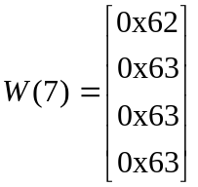

- (AES) Given the plaintext {000102030405060708090A0B0C0D0E0F} and the key {01010101010101010101010101010101}
  - Show the original contents of State, displayed as a 4×4 matrix.
  - Show the value of State after initial AddRoudKey.
  - Show the value of State after SubBytes.
  - Show the value of State after ShiftRows
  - Show the value of State after MixColumns. (15 points)

a.
state = 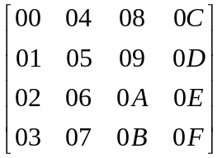
b. Add 0th round key
Key = 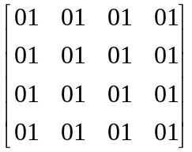

⊕ =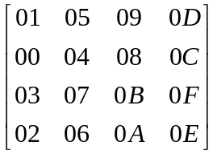

c. Byte Substitution
➔ 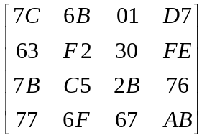
d. Shifting Rows
➔ 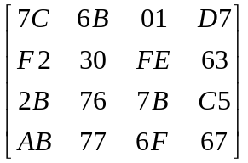

e. Mixing Column

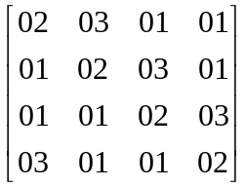= 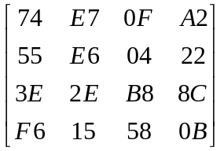

- Compare AES to DES. For each of the following elements of DES, indicate the comparable element in AES or explain why it is not needed in AES.
  - XOR of subkey material with the input to the f function.
  - XOR of the f function output with the left half of the block.
  - The f function.
  - Permutation P.
  - Swapping halves of the block (15 points)

a. AddRoundKey
b. Since AES is not Feistel cipher this step is not necessary.
c. ByteSub
d. ShiftRow and MixColumn.
e. No Swapping of halves.

